Validate CMM xml with mapping V 1.7.2.

OGetGroceryOrder/GroceryOrderData/GroceryOrderHeader/OrderRecordDateInfo/UpdateDtTm

GetGroceryOrder/GroceryOrderData/GroceryOrderHeader/OrderModifyTS

Test Result: Pass

Sample JSON –

{"_id":"5fe41c75019f65001088d0a7","version":4,"modifiedBy":"OSCO-Processor","modifiedDate":"2020-12-23T20:57:38.722-08:00","ttl":-1,"orderNumber":"20064781A","versionNumber":1,"orderStatus":"PAYMENT_REQUESTED","companyId":"1","banner":"carrsqc","isActive":true,"storeNumber":"1739","modifiedReasonCode":"PAYMENT_REQUESTED","orderEditCutoffDate":"2020-12-23T13:00:00.000-08:00","orderCreatedDate":"2020-12-23T20:43:33.351-08:00","fulfillmentSystem":"MANHATTAN","sourceInfo":{"source":"ECOMMERCE","enteredBy":"CUSTOMER","deviceType":"WEB"},"orderTotal":{"amount":"33.98","currency":"USD","txnLevelSavings":[]},"customer":{"customerId":"557-252-1597275418806","clubCardNumber":"49372835334","isSubscription":true,"name":{"firstName":"Prameela","lastName":"Medarametla"},"address":[{"addressType":"SHIPTO","addressLine1":"664 W Evergreen Ave","city":"Palmer","state":"AK","zipCode":"99645","country":"USA"}],"contact":[{"number":"5109962550","type":"MOBILE"}],"email":[{"_id":"rani.dulipalla@gmail.com","type":"PERSONAL"}],"preference":{"optIn":[{"_id":"5109962550","type":"TEXT","isOptin":true}]},"memberId":"903040848134"},"paymentDetails":[{"paymentType":"CREDITCARD","paymentSubType":"MASTERCARD","tokenNumber":"9407672750270035","cardExpiryMonth":"12","cardExpiryYear":"25","zipcode":"19713","reqAuthorizationAmount":"33.98","cardHolderName":"Master card","address":{"zipCode":"19713"},"paymentStatus":{"status":"NOTAUTHORIZED","authorizationCode":"ET101537","authorizationDate":"2020-12-24T04:43:33.375Z"}}],"subOrders":[{"fulfillmentOrderNumber":"20064781011","subOrderNumber":1,"fulfillmentType":"DELIVERY","subOrderType":{"serviceLevel":"EXPRESS","isRescheduled":false},"customerService":{"contact":[{"number":"7983274987","type":"PHONE","subType":"CUST_SERV_PHONE"}]},"deliveryInfo":{"deliverySubType":"RESIDENTIAL","slotInfo":{"slotPlan":"STANDARD","slotType":"ONEHR","slotId":"94c70f71-746c-4c68-99e0-b5e0b079950a","timeZone":"America/Anchorage","startTime":"2020-12-23T22:02:00.000-08:00","endTime":"2020-12-23T23:00:00.000-08:00","shiftNumber":"3","editingCutoffDate":"2020-12-23T13:00:00.000-08:00"},"deliveryServiceType":"ATTENDED","instructions":"","stageByDateTime":"2020-12-23T23:00:00.000-08:00"},"charges":[{"_id":"0000000029103","name":"BagFee","category":"ServiceFee","chargeAmount":{"amount":"0.1","currency":"USD"}}],"promoCodes":[],"routeInfo":{"vanNumber":"UR99","stopNumber":"201"},"tote":{"toteDetails":[{"toteId":"168858","toteTempZone":"CH"}]},"orderLines":[{"itemId":"188560212","itemDescription":"Signature SELECT Bacon Hickory Smoked Thick Cut Value Pack - 48 Oz","orderedQuantity":2,"shortedQuantity":0,"fulfilledQuantity":2,"unitOfMeasure":"LB","unitPrice":{"amount":"16.99","currency":"USD"},"substitutionCode":"2","substitutionValue":"Same Brand Diff Size","isRegulatedItem":false,"fulfilledUpc":[{"upcId":"002113015828","upcQuantity":2,"isSubstituted":false,"upcDescription":"SIGNATURE SELECT BACON HICKORY THICK SLICED","itemPrice":{"itemCode":"0002113015828","scanCode":"0002113015828","entryId":5001,"department":333,"unitPrice":"16.99","basePrice":"16.99","basePricePer":"5.66","price":"16.99","pricePer":"5.66","sellByWeight":"I","averageWeight":"0.0","extendedPrice":"33.98","quantityType":"EA","quantityValue":"2","discountAllowed":true,"itemPluNumber":"0","pointsApplyItem":true,"wic":false,"savings":[],"exceptions":[]},"entryId":5001,"itemCode":"0002113015828"}],"department":{"_id":"333","name":"Meat & Seafood"},"aisle":{"_id":"1_19_8_1","name":"Sausage,Hot Dogs & Bacon"},"shelf":{"_id":"1_19_8_1","name":"Bacon"},"itemPrice":{"itemCode":"0002113015828","entryId":1,"department":333,"basePrice":"16.99","basePricePer":"5.66","pricePer":"5.66","sellByWeight":"I","averageWeight":"0.0","discountAllowed":true,"itemPluNumber":"0","pointsApplyItem":true,"wic":false}}],"subOrderStatus":"CREATED","modifiedReasonCode":"PAYMENT_REQUESTED","exceptions":[{"exceptionType":"EPE","exceptionCode":"EPE_PROMOTIONS_ERROR","exceptionDesc":"EPE system error.","exceptionTime":"2020-12-23T20:57:37.610-08:00"}]}],"storeInfo":[{"key":"isHybridStore","value":"true"},{"key":"isMFC","value":"false"},{"key":"isErumsEnabled","value":"true"},{"key":"isPremiumStore","value":"true"},{"key":"is3PLStore","value":"true"},{"key":"isDUGArrivalEnabled","value":"false"},{"key":"isWYSIWYGEnabled","value":"true"},{"key":"storeTimeZone","value":"America/Anchorage"},{"key":"terminalNumber","value":"99"},{"key":"DAT_FILE_SENT_BY_VEST","value":"false"},{"key":"SENT_TO_VPOS","value":"Y"}],"orderInfo":{},"audit":{"createDate":"2020-12-23T20:43:33.351-08:00","modifiedDate":"2020-12-23T20:57:37.265-08:00","createdBy":"ECOMMERCE","modifiedBy":"MANHATTAN_FEED"},"_class":"com.albertsons.ecommerce.osco.model.OrderModel"}

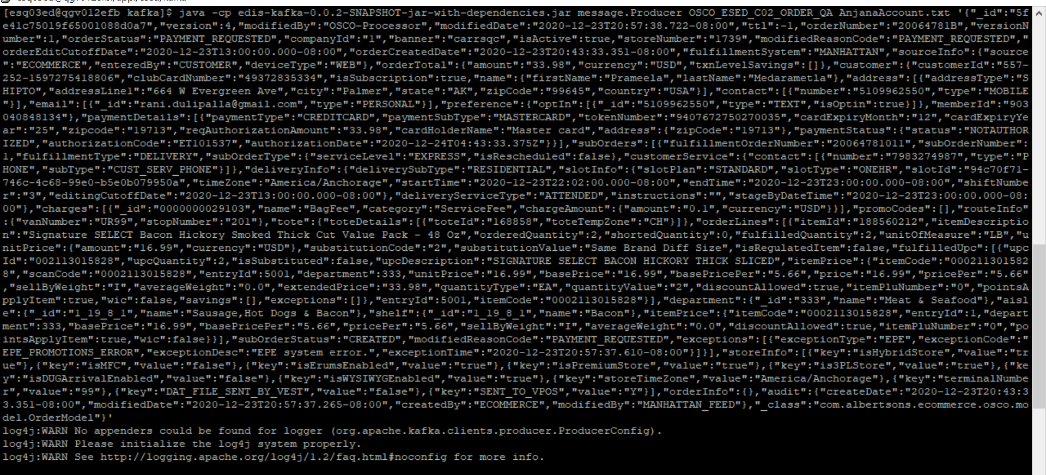

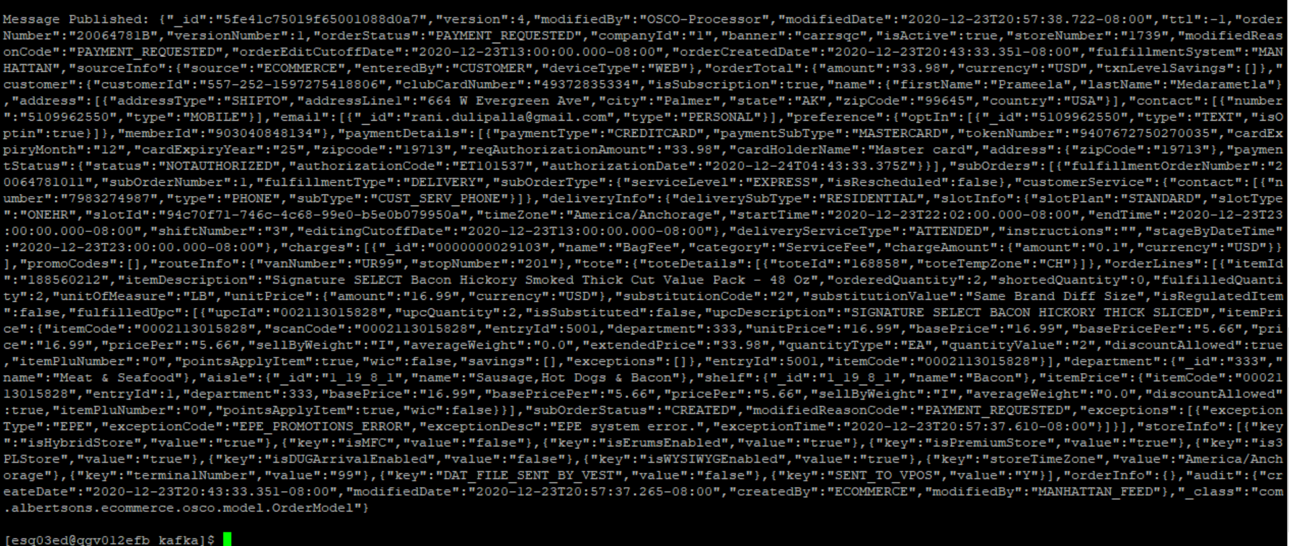

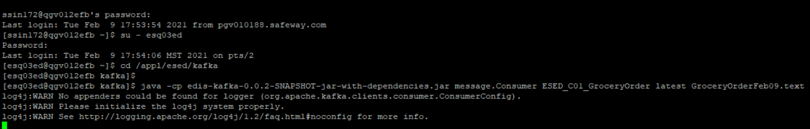

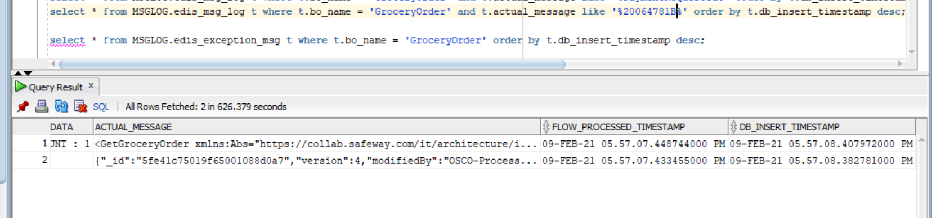

<GetGroceryOrder xmlns:Abs="https://collab.safeway.com/it/architecture/info/default.aspx"><DocumentData><Abs:Document VersionId="1.7.2.085" SystemEnvironmentCd="QA"><Abs:DocumentID>GROCERY_ORDER</Abs:DocumentID><Abs:AlternateDocumentID>OSCO_ESED_C02_ORDER-20210209175707434680</Abs:AlternateDocumentID><Abs:DocumentNm>GroceryOrder</Abs:DocumentNm><Abs:CreationDt>2021-02-09T17:57:07.434680</Abs:CreationDt><Abs:Description>GroceryOrderDetail</Abs:Description><Abs:SourceApplicationCd>OMS</Abs:SourceApplicationCd><Abs:TargetApplicationCd>EDIS</Abs:TargetApplicationCd><Abs:InternalFileTransferInd>Y</Abs:InternalFileTransferInd><Abs:DataClassification><Abs:DataClassificationLevel><Abs:Code>Internal</Abs:Code></Abs:DataClassificationLevel><Abs:BusinessSensitivityLevel><Abs:Code>Low</Abs:Code></Abs:BusinessSensitivityLevel><Abs:PHIdataInd>N</Abs:PHIdataInd><Abs:PCIdataInd>Y</Abs:PCIdataInd><Abs:PIIdataInd>Y</Abs:PIIdataInd></Abs:DataClassification></Abs:Document><Abs:DocumentAction><Abs:ActionTypeCd>UPDATE</Abs:ActionTypeCd><Abs:RecordTypeCd>CHANGE</Abs:RecordTypeCd></Abs:DocumentAction></DocumentData><GroceryOrderData><Abs:GroceryOrderHeader><Abs:OrderId>20064781B</Abs:OrderId><Abs:OrderCreateTS>2020-12-23T20:43:33.351-08:00</Abs:OrderCreateTS><Abs:OrderModifyTS>2020-12-23T20:57:38.722-08:00</Abs:OrderModifyTS><Abs:CompanyId>1</Abs:CompanyId><Abs:VersionNbr>1</Abs:VersionNbr><Abs:OrderStatus><Abs:StatusTypeCd>PAYMENT_REQUESTED</Abs:StatusTypeCd></Abs:OrderStatus><Abs:OrderStatusReasonType/><Abs:OrderActionStatus/><Abs:EditCutoffDtTm>2020-12-23T13:00:00.000-08:00</Abs:EditCutoffDtTm><Abs:EditReasonType><Abs:Code>PAYMENT_REQUESTED</Abs:Code></Abs:EditReasonType><Abs:FulfillingFacility><Abs:RetailStoreId>1739</Abs:RetailStoreId><Abs:BannerCd>carrsqc</Abs:BannerCd><Abs:HybridStoreInd>Y</Abs:HybridStoreInd><Abs:MFCInd>N</Abs:MFCInd><Abs:ERUMSEnabledInd>Y</Abs:ERUMSEnabledInd><Abs:PremiumStoreInd>Y</Abs:PremiumStoreInd><Abs:ThirdPartyDeliveryOnlyInd>Y</Abs:ThirdPartyDeliveryOnlyInd></Abs:FulfillingFacility><Abs:GroceryOrderProfileType><Abs:ProfileType><Abs:Code>WYSIWYG</Abs:Code></Abs:ProfileType><Abs:ProfileValueInd>true</Abs:ProfileValueInd></Abs:GroceryOrderProfileType><Abs:RetailCustomer><Abs:CustomerId>557-252-1597275418806</Abs:CustomerId><Abs:CustomerAlternateId Abs:sequenceNbr="903040848134"/><Abs:CustomerNm><Abs:GivenNm>4MY7T5Tl</Abs:GivenNm><Abs:FamilyNm>Fd9yeY1GJZu</Abs:FamilyNm></Abs:CustomerNm><Abs:Contact><Abs:PhoneFaxContact TypeCode="MOBILE"><Abs:PhoneNbrTxt>DjrwIOebYt</Abs:PhoneNbrTxt></Abs:PhoneFaxContact></Abs:Contact><Abs:Contact><Abs:DigitalContact><Abs:EmailStatuses Abs:typeCode="PERSONAL"/></Abs:DigitalContact></Abs:Contact><Abs:Contact><Abs:Address><Abs:AddressUsageTypeCd>epgjqg</Abs:AddressUsageTypeCd><Abs:AddressLine1txt>2uD C Z9abjDPdu dTT</Abs:AddressLine1txt><Abs:CityNm>KBvewj</Abs:CityNm><Abs:PostalZoneCd>DPyXG</Abs:PostalZoneCd><Abs:StateCd>sWh</Abs:StateCd><Abs:CountryCd>USA</Abs:CountryCd></Abs:Address></Abs:Contact><Abs:ClubCardNbr>tuzhyEHm04T</Abs:ClubCardNbr><Abs:CustomerPreference><Abs:PreferenceType><Abs:Code>TEXT</Abs:Code></Abs:PreferenceType><Abs:OptInInd>true</Abs:OptInInd></Abs:CustomerPreference><Abs:CustomerSubscription><Abs:SubscriptionTypeCd>Subscription</Abs:SubscriptionTypeCd><Abs:OptInInd>true</Abs:OptInInd></Abs:CustomerSubscription></Abs:RetailCustomer><Abs:CurrencyCd>USD</Abs:CurrencyCd><Abs:TotalAmt>33.98</Abs:TotalAmt><Abs:CustomerPayment><Abs:Tender><Abs:TenderId>iBbWM0rqxT7xPEyl</Abs:TenderId><Abs:TenderTypeCd>CREDITCARD</Abs:TenderTypeCd><Abs:TenderSubTypeCd>MASTERCARD</Abs:TenderSubTypeCd><Abs:HolderNm>ykZuKt onyv</Abs:HolderNm><Abs:ExpireMonthYearTxt>B93V</Abs:ExpireMonthYearTxt><Abs:BillingAddress><Abs:PostalZoneCd>kRLvh</Abs:PostalZoneCd></Abs:BillingAddress><Abs:PostalCd>shDZW</Abs:PostalCd><Abs:Token><Abs:TokenId>iBbWM0rqxT7xPEyl</Abs:TokenId><Abs:TokenTypeCd>CREDITCARD</Abs:TokenTypeCd></Abs:Token><Abs:Status><Abs:StatusCd>NOTAUTHORIZED</Abs:StatusCd></Abs:Status><Abs:RequiredAuthAmt>33.98</Abs:RequiredAuthAmt><Abs:AuthCd>ICUia5JH</Abs:AuthCd><Abs:AuthDt>2020-12-24T04:43:33.375Z</Abs:AuthDt></Abs:Tender></Abs:CustomerPayment><Abs:CustomerSavings/><Abs:OrderRecordDateInfo><Abs:CreateDtTm>2020-12-23T20:43:33.351-08:00</Abs:CreateDtTm><Abs:CreateUserId>CUSTOMER</Abs:CreateUserId><Abs:UpdateDtTm>2020-12-23T20:57:38.722-08:00</Abs:UpdateDtTm><Abs:UpdateUserId>MANHATTAN_FEED</Abs:UpdateUserId></Abs:OrderRecordDateInfo><Abs:Device><Abs:Code>WEB</Abs:Code></Abs:Device><Abs:OrderCreatedDeviceType><Abs:Code>WEB</Abs:Code></Abs:OrderCreatedDeviceType><Abs:AffiliatePartnerType/><Abs:OrderSourceSystemType><Abs:Code>ECOMMERCE</Abs:Code></Abs:OrderSourceSystemType><Abs:FulFillmentSystemType><Abs:Code>MANHATTAN</Abs:Code></Abs:FulFillmentSystemType></Abs:GroceryOrderHeader><Abs:GrocerySubOrder><Abs:SubOrderNbr>1</Abs:SubOrderNbr><Abs:SubOrderStatus><Abs:StatusTypeCd>CREATED</Abs:StatusTypeCd></Abs:SubOrderStatus><Abs:StatusReasonType/><Abs:SubOrderActionStatus/><Abs:SubOrderServiceLevelType><Abs:Code>EXPRESS</Abs:Code></Abs:SubOrderServiceLevelType><Abs:GroceryOrderDetail><Abs:CartLineNbr>1</Abs:CartLineNbr><Abs:ItemId><Abs:SystemSpecificItemId>188560212</Abs:SystemSpecificItemId><Abs:InternalItemId>0002113015828</Abs:InternalItemId><Abs:BaseProductNbr>188560212</Abs:BaseProductNbr><Abs:PLUCd>0</Abs:PLUCd><Abs:ItemDescription>Signature SELECT Bacon Hickory Smoked Thick Cut Value Pack - 48 Oz</Abs:ItemDescription></Abs:ItemId><Abs:BasePriceAmt>16.9900</Abs:BasePriceAmt><Abs:UnitPriceAmt>16.9900</Abs:UnitPriceAmt><Abs:Quantity>2.0000</Abs:Quantity><Abs:UOM><Abs:UOMCd>LB</Abs:UOMCd></Abs:UOM><Abs:DiscountAllowedInd>true</Abs:DiscountAllowedInd><Abs:RewardAllowedInd>true</Abs:RewardAllowedInd><Abs:SubstitutionType><Abs:Code>2</Abs:Code><Abs:Description>Same Brand Diff Size</Abs:Description></Abs:SubstitutionType><Abs:CurrencyCd>USD</Abs:CurrencyCd><Abs:RegulatedItemInd>false</Abs:RegulatedItemInd><Abs:CouponPLUNbr>0</Abs:CouponPLUNbr><Abs:Department><Abs:Code>333</Abs:Code></Abs:Department><Abs:WICItemInd>false</Abs:WICItemInd><Abs:DeliveredItem><Abs:DeliveredItemLineNbr>5001</Abs:DeliveredItemLineNbr><Abs:FulfillmentOrderId>20064781011</Abs:FulfillmentOrderId><Abs:Item><Abs:UPC><Abs:UPCNbr>002113015828</Abs:UPCNbr></Abs:UPC><Abs:SystemSpecificItemId>188560212</Abs:SystemSpecificItemId><Abs:InternalItemId>0002113015828</Abs:InternalItemId><Abs:PLUCd>0</Abs:PLUCd><Abs:BaseProductNbr>188560212</Abs:BaseProductNbr></Abs:Item><Abs:SubstitutedItemInd>false</Abs:SubstitutedItemInd><Abs:Quantity>2</Abs:Quantity><Abs:UOM><Abs:UOMCd>EA</Abs:UOMCd></Abs:UOM><Abs:BasePriceAmt>16.9900</Abs:BasePriceAmt><Abs:UnitPriceAmt>16.9900</Abs:UnitPriceAmt><Abs:ExtendedUnitPriceAmt>33.9800</Abs:ExtendedUnitPriceAmt><Abs:RegulatedItemInd>false</Abs:RegulatedItemInd><Abs:CouponPLUNbr>0</Abs:CouponPLUNbr><Abs:RewardAllowedInd>true</Abs:RewardAllowedInd><Abs:DiscountAllowedInd>true</Abs:DiscountAllowedInd><Abs:WICItemInd>false</Abs:WICItemInd><Abs:CustomerSavings/></Abs:DeliveredItem><Abs:OrderQty>2.0000</Abs:OrderQty><Abs:FulfilledQty>2.0000</Abs:FulfilledQty><Abs:CustomerSavings/></Abs:GroceryOrderDetail><Abs:FullFillmentType><Abs:Code>DELIVERY</Abs:Code></Abs:FullFillmentType><Abs:PickupInfo><Abs:PickupSlot/><Abs:PickupSlotType/></Abs:PickupInfo><Abs:DeliveryInfo><Abs:CustomerType><Abs:Code>RESIDENTIAL</Abs:Code></Abs:CustomerType><Abs:DeliverySlotId>94c70f71-746c-4c68-99e0-b5e0b079950a</Abs:DeliverySlotId><Abs:DeliverySlotType><Abs:Code>ONEHR</Abs:Code></Abs:DeliverySlotType><Abs:DeliveryServiceType><Abs:Code>ATTENDED</Abs:Code></Abs:DeliveryServiceType><Abs:SlotPlan><Abs:Code>STANDARD</Abs:Code></Abs:SlotPlan><Abs:StartDttm>2020-12-23T22:02:00.000-08:00</Abs:StartDttm><Abs:EndDttm>2020-12-23T23:00:00.000-08:00</Abs:EndDttm><Abs:SlotExpiryDttm>2020-12-23T23:00:00.000-08:00</Abs:SlotExpiryDttm><Abs:StageByDttm>2020-12-23T23:00:00.000-08:00</Abs:StageByDttm><Abs:EditCutoffDtTm>2020-12-23T13:00:00.000-08:00</Abs:EditCutoffDtTm><Abs:CustomerInstructionTxt></Abs:CustomerInstructionTxt><Abs:DeliveryTimeZoneCd>America/Anchorage</Abs:DeliveryTimeZoneCd></Abs:DeliveryInfo><Abs:ChargeInfo><Abs:Charge><Abs:Description>BagFee</Abs:Description></Abs:Charge><Abs:ChargeCategory><Abs:Code>ServiceFee</Abs:Code></Abs:ChargeCategory><Abs:ChargeAmt>0.10</Abs:ChargeAmt><Abs:CurrencyCd>USD</Abs:CurrencyCd></Abs:ChargeInfo><Abs:CustomerService><Abs:PhoneFaxContact TypeCode="PHONE"><Abs:PhoneNbrTxt>7983274987</Abs:PhoneNbrTxt><Abs:PhonePurposes><Abs:PurposeDsc>CUST_SERV_PHONE</Abs:PurposeDsc></Abs:PhonePurposes></Abs:PhoneFaxContact></Abs:CustomerService><Abs:InstructionTxt></Abs:InstructionTxt><Abs:GrocerySubOrderExceptionType><Abs:ExceptionType><Abs:Code>EPE</Abs:Code></Abs:ExceptionType><Abs:ExceptionCd>EPE_PROMOTIONS_ERROR</Abs:ExceptionCd><Abs:ExceptionDsc>EPE system error.</Abs:ExceptionDsc><Abs:ExceptionCreateTs>2020-12-23T20:57:37.610-08:00</Abs:ExceptionCreateTs></Abs:GrocerySubOrderExceptionType></Abs:GrocerySubOrder></GroceryOrderData></GetGroceryOrder>

**Sample-2JSON**

**{"_id":"5fe3e8ae019f65001088d02b","version":4,"modifiedBy":"OSCO-Processor","modifiedDate":"2020-12-23T19:03:38.307-08:00","ttl":-1,"orderNumber":"20064742A","versionNumber":1,"orderStatus":"PAYMENT_REQUESTED","companyId":"1","banner":"carrsqc","isActive":true,"storeNumber":"1739","modifiedReasonCode":"PAYMENT_REQUESTED","orderEditCutoffDate":"2020-12-23T13:00:00.000-08:00","orderCreatedDate":"2020-12-23T17:02:37.844-08:00","fulfillmentSystem":"MANHATTAN","sourceInfo":{"source":"ECOMMERCE","enteredBy":"CUSTOMER","deviceType":"WEB"},"orderTotal":{"amount":"57.86","currency":"USD","totalCardSavings":"0","cardSavings":[],"txnLevelSavings":[]},"customer":{"customerId":"557-252-1597275418806","clubCardNumber":"49372835334","isSubscription":true,"name":{"firstName":"Prameela","lastName":"Medarametla"},"address":[{"addressType":"SHIPTO","addressLine1":"664 W Evergreen Ave","city":"Palmer","state":"AK","zipCode":"99645","country":"USA"}],"contact":[{"number":"5109962550","type":"MOBILE"}],"email":[{"_id":"rani.dulipalla@gmail.com","type":"PERSONAL"}],"preference":{"optIn":[{"_id":"5109962550","type":"TEXT","isOptin":true}]},"memberId":"903040848134"},"paymentDetails":[{"paymentType":"CREDITCARD","paymentSubType":"MASTERCARD","tokenNumber":"9407672750270035","cardExpiryMonth":"12","cardExpiryYear":"25","zipcode":"19713","reqAuthorizationAmount":"57.86","cardHolderName":"Master card","address":{"zipCode":"19713"},"paymentStatus":{"status":"NOTAUTHORIZED","authorizationCode":"ET147742","authorizationDate":"2020-12-24T01:02:37.907Z"}}],"subOrders":[{"fulfillmentOrderNumber":"20064742011","subOrderNumber":1,"fulfillmentType":"DELIVERY","subOrderType":{"serviceLevel":"EXPRESS","isRescheduled":false},"customerService":{"contact":[{"number":"7983274987","type":"PHONE","subType":"CUST_SERV_PHONE"}]},"deliveryInfo":{"deliverySubType":"RESIDENTIAL","slotInfo":{"slotPlan":"STANDARD","slotType":"ONEHR","slotId":"5b04743b-89bc-4270-9a49-43737f4c15c2","timeZone":"America/Anchorage","startTime":"2020-12-23T19:02:00.000-08:00","endTime":"2020-12-23T20:00:00.000-08:00","shiftNumber":"3","editingCutoffDate":"2020-12-23T13:00:00.000-08:00"},"deliveryServiceType":"ATTENDED","instructions":"","stageByDateTime":"2020-12-23T20:00:00.000-08:00"},"charges":[{"_id":"0000000029103","name":"BagFee","category":"ServiceFee","chargeAmount":{"amount":"0.1","currency":"USD"}}],"promoCodes":[],"routeInfo":{"vanNumber":"UR99","stopNumber":"200"},"tote":{"toteDetails":[{"toteId":"168827","toteTempZone":"CH"}]},"orderLines":[{"itemId":"184290007","itemDescription":"Broccoli Crowns","orderedQuantity":2,"shortedQuantity":0,"fulfilledQuantity":2,"unitOfMeasure":"LB","unitPrice":{"amount":"1.87","currency":"USD"},"substitutionCode":"2","substitutionValue":"Same Brand Diff Size","isRegulatedItem":false,"fulfilledUpc":[{"upcId":"048429000701","upcQuantity":2,"isSubstituted":true,"upcDescription":"False Item","itemPrice":{"itemCode":"0048429000000","scanCode":"0048429000701","entryId":5002,"department":0,"discountAllowed":false,"itemPluNumber":"84290","pointsApplyItem":false,"wic":false,"savings":[{"offerId":"684172","externalOfferId":"684172","categoryId":0,"calculateUsage":false}],"exceptions":[{"exceptionType":"PRICING","exceptionCode":"ITEM_NOT_FOUND","exceptionDesc":"Product information not found","exceptionTime":"2020-12-23T19:03:37.428-08:00"}]},"entryId":5002,"scanWeight":"7.01","itemCode":"0048429000000"}],"department":{"_id":"329","name":"Fruits & Vegetables"},"aisle":{"_id":"1_23_2_4","name":"Fresh Vegetables & Herbs"},"shelf":{"_id":"1_23_2_4","name":"Broccoli & Cauliflower"},"itemPrice":{"itemCode":"0048429000701","entryId":2,"department":329,"unitPrice":"2.49","basePrice":"1.87","basePricePer":"2.49","pricePer":"2.49","sellByWeight":"W","averageWeight":"0.75","clubCardSaving":"0.0","extendedPrice":"3.74","quantityType":"WV","quantityValue":"1.5","discountAllowed":true,"itemPluNumber":"3082","pointsApplyItem":true,"wic":true,"netPromotionAmount":"0.74","savings":[{"offerId":"684172","externalOfferId":"684172","categoryId":67,"categoryName":"007-J4U Manufacturer eCoupons","source":"CPE","netPromotionAmount":"0.74","programCode":"MF","startDate":"2020-10-05T16:00:00.000-08:00","endDate":"2021-11-19T16:00:00.000-08:00","discountAmount":"3.0","discountType":"Fixed Amount Off (Weight/Volume)","description":"EPE-WYSIWYG-MF-Dollaroff - Flex false 1017","discountMessage":"","discountLevel":"Item Level","calculateUsage":false}]}},{"itemId":"184710053","itemDescription":"Cilantro Organic","orderedQuantity":2,"shortedQuantity":0,"fulfilledQuantity":2,"unitOfMeasure":"EA","unitPrice":{"amount":"1.99","currency":"USD"},"substitutionCode":"2","substitutionValue":"Same Brand Diff Size","isRegulatedItem":false,"fulfilledUpc":[{"upcId":"002113079909","upcQuantity":2,"isSubstituted":true,"upcDescription":"SIGNATURE CARE LIQUID HAND SOAP ALOE","itemPrice":{"itemCode":"0002113079909","scanCode":"0002113079909","entryId":5004,"department":312,"unitPrice":"1.50","basePrice":"1.50","basePricePer":"0.20","price":"1.50","pricePer":"0.20","sellByWeight":"I","averageWeight":"0.0","clubCardSaving":"0.00","extendedPrice":"3.00","quantityType":"EA","quantityValue":"2.0","discountAllowed":true,"linkPluNumber":"248000185249","pointsApplyItem":true,"wic":false,"startDate":"2020-11-29T16:00:01.000-08:00","endDate":"2020-12-27T15:59:00.000-08:00","savings":[],"exceptions":[]},"entryId":5004,"itemCode":"0002113079909"}],"department":{"_id":"329","name":"Fruits & Vegetables"},"aisle":{"_id":"1_23_2_11","name":"Fresh Vegetables & Herbs"},"shelf":{"_id":"1_23_2_11","name":"Herbs"},"itemPrice":{"itemCode":"0003338390419","entryId":1,"department":329,"unitPrice":"1.99","basePrice":"1.99","basePricePer":"1.99","pricePer":"1.99","sellByWeight":"I","averageWeight":"0.0","clubCardSaving":"0.0","extendedPrice":"3.98","quantityType":"EA","quantityValue":"2.0","discountAllowed":true,"itemPluNumber":"0","pointsApplyItem":true,"wic":false,"netPromotionAmount":"3.98"}},{"itemId":"188100109","itemDescription":"Ground Beef 80% Lean 20% Fat Value Pack - 3.50 Lbs.","orderedQuantity":2,"shortedQuantity":0,"fulfilledQuantity":2,"unitOfMeasure":"LB","unitPrice":{"amount":"27.97","currency":"USD"},"substitutionCode":"2","substitutionValue":"Same Brand Diff Size","isRegulatedItem":false,"fulfilledUpc":[{"upcId":"020120300000","upcQuantity":1,"isSubstituted":true,"upcDescription":"False Item","itemPrice":{"itemCode":"0020120300000","scanCode":"0020120300000","entryId":5006,"department":0,"quantityValue":"1.0","discountAllowed":false,"pointsApplyItem":false,"wic":false,"savings":[{"offerId":"617529","externalOfferId":"77509408-D","categoryId":0,"calculateUsage":false}],"exceptions":[{"exceptionType":"PRICING","exceptionCode":"ITEM_NOT_FOUND","exceptionDesc":"Product information not found","exceptionTime":"2020-12-23T19:03:37.428-08:00"}]},"entryId":5006,"itemCode":"0020120300000"},{"upcId":"020120300000","upcQuantity":1,"isSubstituted":true,"upcDescription":"False Item","itemPrice":{"itemCode":"0020120300000","scanCode":"0020120300000","entryId":5007,"department":0,"quantityValue":"1.0","discountAllowed":false,"pointsApplyItem":false,"wic":false,"savings":[{"offerId":"617529","externalOfferId":"77509408-D","categoryId":0,"calculateUsage":false}],"exceptions":[{"exceptionType":"PRICING","exceptionCode":"ITEM_NOT_FOUND","exceptionDesc":"Product information not found","exceptionTime":"2020-12-23T19:03:37.428-08:00"}]},"entryId":5007,"itemCode":"0020120300000"}],"department":{"_id":"333","name":"Meat & Seafood"},"aisle":{"_id":"1_19_1_5","name":"Beef"},"shelf":{"_id":"1_19_1_5","name":"Ground Beef"},"itemPrice":{"itemCode":"0020164800000","entryId":3,"department":333,"unitPrice":"7.99","basePrice":"27.97","basePricePer":"7.99","pricePer":"7.99","sellByWeight":"P","averageWeight":"3.5","clubCardSaving":"0.0","extendedPrice":"55.94","quantityType":"WV","quantityValue":"7.0","discountAllowed":true,"itemPluNumber":"0","pointsApplyItem":true,"wic":false,"netPromotionAmount":"53.14","savings":[{"offerId":"617529","externalOfferId":"77509408-D","categoryId":69,"categoryName":"003-J4U Store eCoupons (elec)","source":"CPE","netPromotionAmount":"53.14","programCode":"SC","startDate":"2020-10-05T16:00:00.000-08:00","endDate":"2022-02-28T16:00:00.000-08:00","discountAmount":"2.8","discountType":"Percent Off","description":"add","discountMessage":"b34","discountLevel":"Item Level","calculateUsage":false}]}}],"subOrderStatus":"CREATED","modifiedReasonCode":"PAYMENT_REQUESTED","exceptions":[]}],"storeInfo":[{"key":"isHybridStore","value":"true"},{"key":"isMFC","value":"false"},{"key":"isErumsEnabled","value":"true"},{"key":"isPremiumStore","value":"true"},{"key":"is3PLStore","value":"true"},{"key":"isDUGArrivalEnabled","value":"false"},{"key":"isWYSIWYGEnabled","value":"true"},{"key":"storeTimeZone","value":"America/Anchorage"},{"key":"terminalNumber","value":"99"},{"key":"DAT_FILE_SENT_BY_VEST","value":"false"},{"key":"SENT_TO_VPOS","value":"Y"}],"orderInfo":{"receiptMessage":[{"messageNumber":"1","printLine":"--------------------------------------"},{"messageNumber":"2","printLine":"POINTS EARNED TODAY "},{"messageNumber":"3","printLine":"Base Points 0"},{"messageNumber":"4","printLine":"TOTAL 0"},{"messageNumber":"5","printLine":"--------------------------------------"},{"messageNumber":"6","printLine":"Points Towards Next Reward 0 of 100"},{"messageNumber":"7","printLine":"REWARDS AVAILABLE 0"}]},"audit":{"createDate":"2020-12-23T17:02:37.844-08:00","modifiedDate":"2020-12-23T19:03:35.751-08:00","createdBy":"ECOMMERCE","modifiedBy":"MANHATTAN_FEED"},"_class":"com.albertsons.ecommerce.osco.model.OrderModel"}**

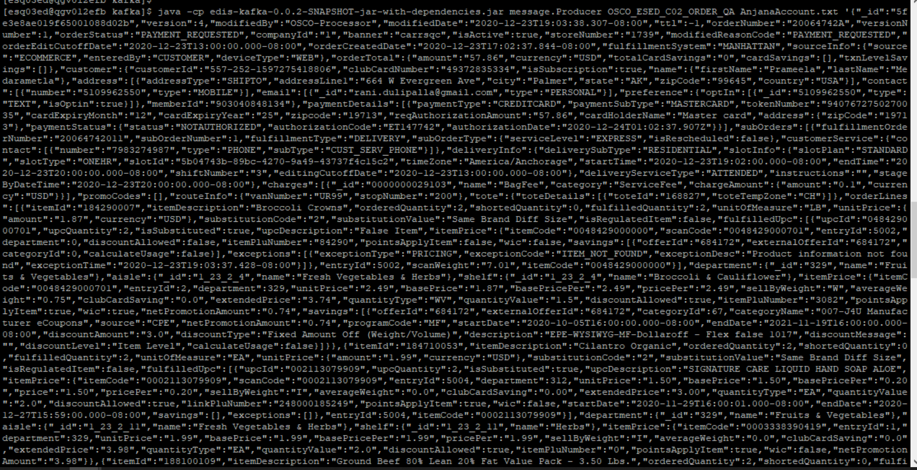

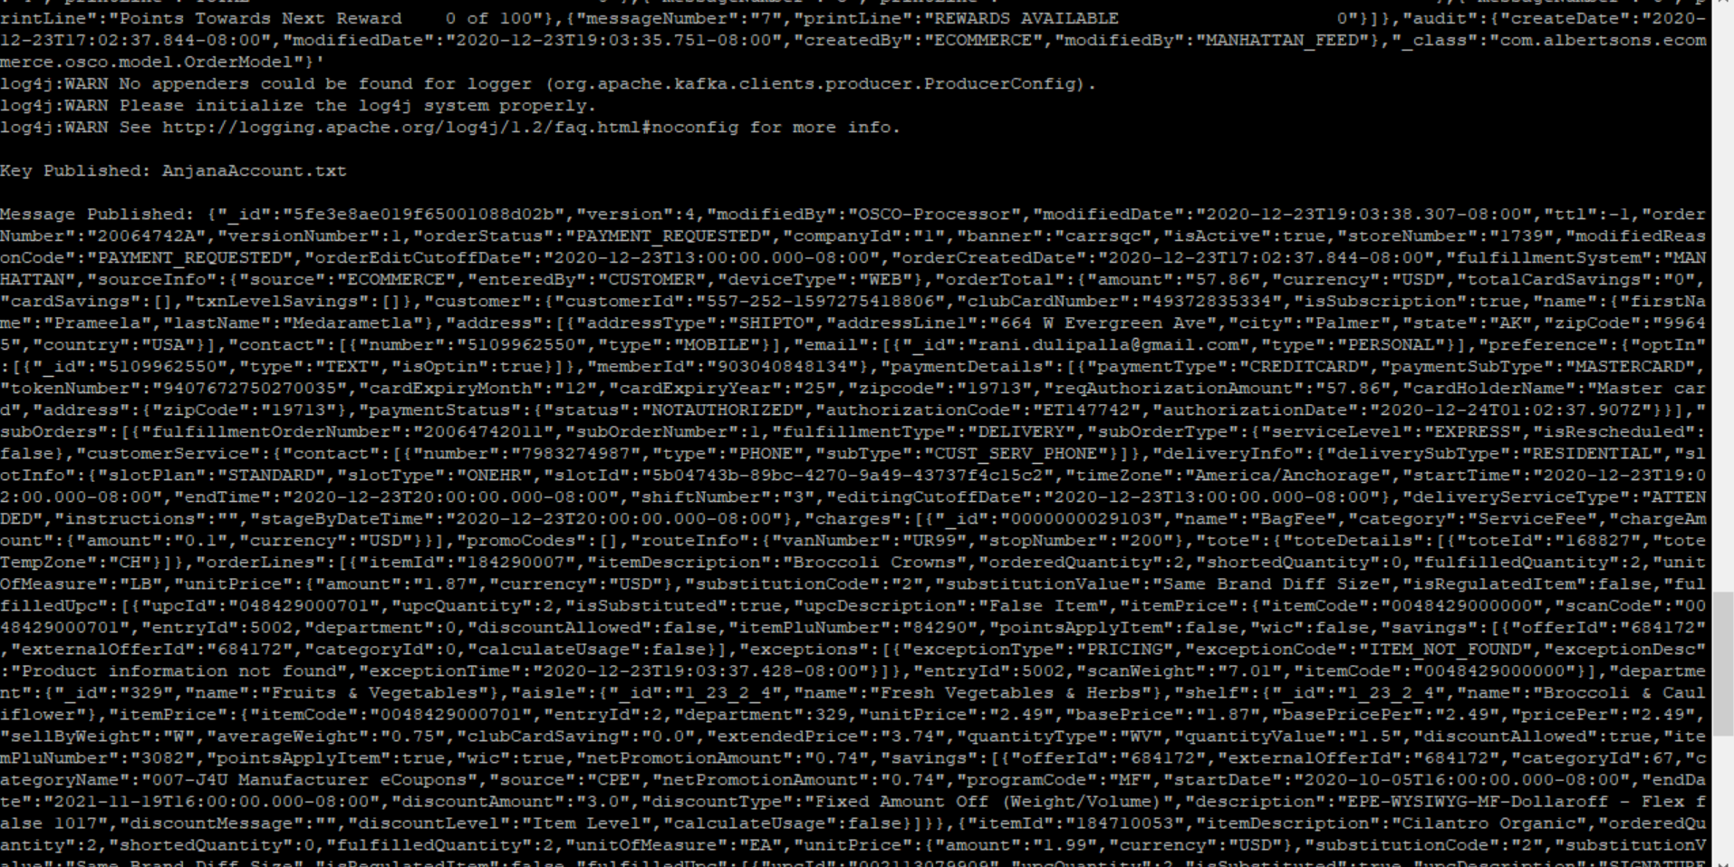

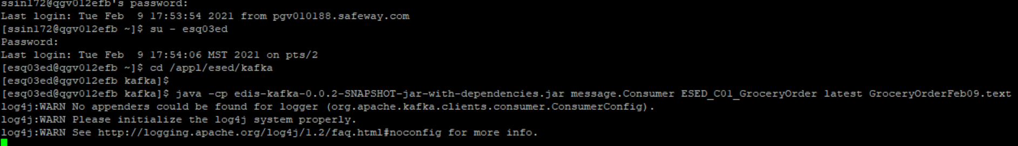

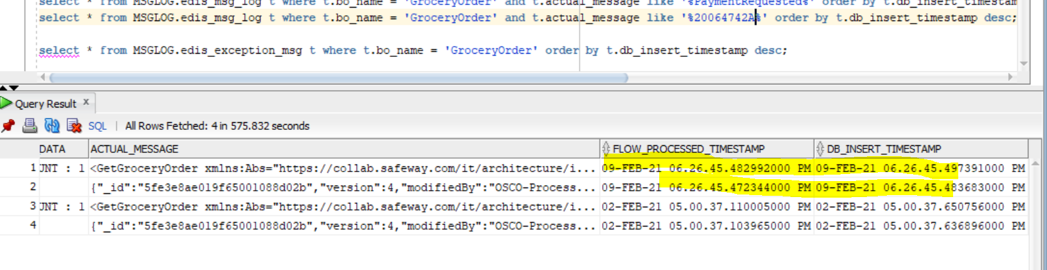

**<GetGroceryOrder**

**xmlns:Abs="https://collab.safeway.com/it/architecture/info/default.aspx">**

**<DocumentData>**

**<Abs:Document VersionId="1.7.2.085" SystemEnvironmentCd="QA">**

**<Abs:DocumentID>GROCERY_ORDER</Abs:DocumentID>**

**<Abs:AlternateDocumentID>OSCO_ESED_C02_ORDER-20210209182645473245</Abs:AlternateDocumentID>**

**<Abs:DocumentNm>GroceryOrder</Abs:DocumentNm>**

**<Abs:CreationDt>2021-02-09T18:26:45.473245</Abs:CreationDt>**

**<Abs:Description>GroceryOrderDetail</Abs:Description>**

**<Abs:SourceApplicationCd>OMS</Abs:SourceApplicationCd>**

**<Abs:TargetApplicationCd>EDIS</Abs:TargetApplicationCd>**

**<Abs:InternalFileTransferInd>Y</Abs:InternalFileTransferInd>**

**<Abs:DataClassification>**

**<Abs:DataClassificationLevel>**

**<Abs:Code>Internal</Abs:Code>**

**</Abs:DataClassificationLevel>**

**<Abs:BusinessSensitivityLevel>**

**<Abs:Code>Low</Abs:Code>**

**</Abs:BusinessSensitivityLevel>**

**<Abs:PHIdataInd>N</Abs:PHIdataInd>**

**<Abs:PCIdataInd>Y</Abs:PCIdataInd>**

**<Abs:PIIdataInd>Y</Abs:PIIdataInd>**

**</Abs:DataClassification>**

**</Abs:Document>**

**<Abs:DocumentAction>**

**<Abs:ActionTypeCd>UPDATE</Abs:ActionTypeCd>**

**<Abs:RecordTypeCd>CHANGE</Abs:RecordTypeCd>**

**</Abs:DocumentAction>**

**</DocumentData>**

**<GroceryOrderData>**

**<Abs:GroceryOrderHeader>**

**<Abs:OrderId>20064742A</Abs:OrderId>**

**<Abs:OrderCreateTS>2020-12-23T17:02:37.844-08:00</Abs:OrderCreateTS>**

**<Abs:OrderModifyTS>2020-12-23T19:03:38.307-08:00</Abs:OrderModifyTS>**

**<Abs:CompanyId>1</Abs:CompanyId>**

**<Abs:VersionNbr>1</Abs:VersionNbr>**

**<Abs:OrderStatus>**

**<Abs:StatusTypeCd>PAYMENT_REQUESTED</Abs:StatusTypeCd>**

**</Abs:OrderStatus>**

**<Abs:OrderStatusReasonType/>**

**<Abs:OrderActionStatus/>**

**<Abs:EditCutoffDtTm>2020-12-23T13:00:00.000-08:00</Abs:EditCutoffDtTm>**

**<Abs:EditReasonType>**

**<Abs:Code>PAYMENT_REQUESTED</Abs:Code>**

**</Abs:EditReasonType>**

**<Abs:FulfillingFacility>**

**<Abs:RetailStoreId>1739</Abs:RetailStoreId>**

**<Abs:BannerCd>carrsqc</Abs:BannerCd>**

**<Abs:HybridStoreInd>Y</Abs:HybridStoreInd>**

**<Abs:MFCInd>N</Abs:MFCInd>**

**<Abs:ERUMSEnabledInd>Y</Abs:ERUMSEnabledInd>**

**<Abs:PremiumStoreInd>Y</Abs:PremiumStoreInd>**

**<Abs:ThirdPartyDeliveryOnlyInd>Y</Abs:ThirdPartyDeliveryOnlyInd>**

**</Abs:FulfillingFacility>**

**<Abs:GroceryOrderProfileType>**

**<Abs:ProfileType>**

**<Abs:Code>WYSIWYG</Abs:Code>**

**</Abs:ProfileType>**

**<Abs:ProfileValueInd>true</Abs:ProfileValueInd>**

**</Abs:GroceryOrderProfileType>**

**<Abs:RetailCustomer>**

**<Abs:CustomerId>557-252-1597275418806</Abs:CustomerId>**

**<Abs:CustomerAlternateId Abs:sequenceNbr="903040848134"/>**

**<Abs:CustomerNm>**

**<Abs:GivenNm>4MY7T5Tl</Abs:GivenNm>**

**<Abs:FamilyNm>Fd9yeY1GJZu</Abs:FamilyNm>**

**</Abs:CustomerNm>**

**<Abs:Contact>**

**<Abs:PhoneFaxContact TypeCode="MOBILE">**

**<Abs:PhoneNbrTxt>DjrwIOebYt</Abs:PhoneNbrTxt>**

**</Abs:PhoneFaxContact>**

**</Abs:Contact>**

**<Abs:Contact>**

**<Abs:DigitalContact>**

**<Abs:EmailStatuses Abs:typeCode="PERSONAL"/>**

**</Abs:DigitalContact>**

**</Abs:Contact>**

**<Abs:Contact>**

**<Abs:Address>**

**<Abs:AddressUsageTypeCd>epgjqg</Abs:AddressUsageTypeCd>**

**<Abs:AddressLine1txt>2uD C Z9abjDPdu dTT</Abs:AddressLine1txt>**

**<Abs:CityNm>KBvewj</Abs:CityNm>**

**<Abs:PostalZoneCd>DPyXG</Abs:PostalZoneCd>**

**<Abs:StateCd>sWh</Abs:StateCd>**

**<Abs:CountryCd>USA</Abs:CountryCd>**

**</Abs:Address>**

**</Abs:Contact>**

**<Abs:ClubCardNbr>tuzhyEHm04T</Abs:ClubCardNbr>**

**<Abs:CustomerPreference>**

**<Abs:PreferenceType>**

**<Abs:Code>TEXT</Abs:Code>**

**</Abs:PreferenceType>**

**<Abs:OptInInd>true</Abs:OptInInd>**

**</Abs:CustomerPreference>**

**<Abs:CustomerSubscription>**

**<Abs:SubscriptionTypeCd>Subscription</Abs:SubscriptionTypeCd>**

**<Abs:OptInInd>true</Abs:OptInInd>**

**</Abs:CustomerSubscription>**

**</Abs:RetailCustomer>**

**<Abs:CurrencyCd>USD</Abs:CurrencyCd>**

**<Abs:TotalAmt>57.86</Abs:TotalAmt>**

**<Abs:CustomerPayment>**

**<Abs:Tender>**

**<Abs:TenderId>iBbWM0rqxT7xPEyl</Abs:TenderId>**

**<Abs:TenderTypeCd>CREDITCARD</Abs:TenderTypeCd>**

**<Abs:TenderSubTypeCd>MASTERCARD</Abs:TenderSubTypeCd>**

**<Abs:HolderNm>ykZuKt onyv</Abs:HolderNm>**

**<Abs:ExpireMonthYearTxt>B93V</Abs:ExpireMonthYearTxt>**

**<Abs:BillingAddress>**

**<Abs:PostalZoneCd>kRLvh</Abs:PostalZoneCd>**

**</Abs:BillingAddress>**

**<Abs:PostalCd>shDZW</Abs:PostalCd>**

**<Abs:Token>**

**<Abs:TokenId>iBbWM0rqxT7xPEyl</Abs:TokenId>**

**<Abs:TokenTypeCd>CREDITCARD</Abs:TokenTypeCd>**

**</Abs:Token>**

**<Abs:Status>**

**<Abs:StatusCd>NOTAUTHORIZED</Abs:StatusCd>**

**</Abs:Status>**

**<Abs:RequiredAuthAmt>57.86</Abs:RequiredAuthAmt>**

**<Abs:AuthCd>f82EdgmK</Abs:AuthCd>**

**<Abs:AuthDt>2020-12-24T01:02:37.907Z</Abs:AuthDt>**

**</Abs:Tender>**

**</Abs:CustomerPayment>**

**<Abs:CustomerSavings>**

**<Abs:TotalCustomerSavingsAmt>0.00</Abs:TotalCustomerSavingsAmt>**

**</Abs:CustomerSavings>**

**<Abs:OrderRecordDateInfo>**

**<Abs:CreateDtTm>2020-12-23T17:02:37.844-08:00</Abs:CreateDtTm>**

**<Abs:CreateUserId>CUSTOMER</Abs:CreateUserId>**

**<Abs:UpdateDtTm>2020-12-23T19:03:38.307-08:00</Abs:UpdateDtTm>**

**<Abs:UpdateUserId>MANHATTAN_FEED</Abs:UpdateUserId>**

**</Abs:OrderRecordDateInfo>**

**<Abs:Device>**

**<Abs:Code>WEB</Abs:Code>**

**</Abs:Device>**

**<Abs:OrderCreatedDeviceType>**

**<Abs:Code>WEB</Abs:Code>**

**</Abs:OrderCreatedDeviceType>**

**<Abs:AffiliatePartnerType/>**

**<Abs:OrderSourceSystemType>**

**<Abs:Code>ECOMMERCE</Abs:Code>**

**</Abs:OrderSourceSystemType>**

**<Abs:FulFillmentSystemType>**

**<Abs:Code>MANHATTAN</Abs:Code>**

**</Abs:FulFillmentSystemType>**

**</Abs:GroceryOrderHeader>**

**<Abs:GrocerySubOrder>**

**<Abs:SubOrderNbr>1</Abs:SubOrderNbr>**

**<Abs:SubOrderStatus>**

**<Abs:StatusTypeCd>CREATED</Abs:StatusTypeCd>**

**</Abs:SubOrderStatus>**

**<Abs:StatusReasonType/>**

**<Abs:SubOrderActionStatus/>**

**<Abs:SubOrderServiceLevelType>**

**<Abs:Code>EXPRESS</Abs:Code>**

**</Abs:SubOrderServiceLevelType>**

**<Abs:GroceryOrderDetail>**

**<Abs:CartLineNbr>2</Abs:CartLineNbr>**

**<Abs:ItemId>**

**<Abs:SystemSpecificItemId>184290007</Abs:SystemSpecificItemId>**

**<Abs:InternalItemId>0048429000701</Abs:InternalItemId>**

**<Abs:BaseProductNbr>184290007</Abs:BaseProductNbr>**

**<Abs:PLUCd>3082</Abs:PLUCd>**

**<Abs:ItemDescription>Broccoli Crowns</Abs:ItemDescription>**

**</Abs:ItemId>**

**<Abs:BasePriceAmt>1.8700</Abs:BasePriceAmt>**

**<Abs:UnitPriceAmt>1.8700</Abs:UnitPriceAmt>**

**<Abs:ExtendedUnitPriceAmt>3.7400</Abs:ExtendedUnitPriceAmt>**

**<Abs:Quantity>2.0000</Abs:Quantity>**

**<Abs:UOM>**

**<Abs:UOMCd>LB</Abs:UOMCd>**

**</Abs:UOM>**

**<Abs:DiscountAllowedInd>true</Abs:DiscountAllowedInd>**

**<Abs:RewardAllowedInd>true</Abs:RewardAllowedInd>**

**<Abs:SubstitutionType>**

**<Abs:Code>2</Abs:Code>**

**<Abs:Description>Same Brand Diff Size</Abs:Description>**

**</Abs:SubstitutionType>**

**<Abs:CurrencyCd>USD</Abs:CurrencyCd>**

**<Abs:RegulatedItemInd>false</Abs:RegulatedItemInd>**

**<Abs:CouponPLUNbr>3082</Abs:CouponPLUNbr>**

**<Abs:CustomerOffers>**

**<Abs:OfferId>684172</Abs:OfferId>**

**<Abs:ReferenceOfferId>684172</Abs:ReferenceOfferId>**

**<Abs:OfferSourceType>**

**<Abs:Code>CPE</Abs:Code>**

**</Abs:OfferSourceType>**

**</Abs:CustomerOffers>**

**<Abs:Department>**

**<Abs:Code>329</Abs:Code>**

**</Abs:Department>**

**<Abs:WICItemInd>true</Abs:WICItemInd>**

**<Abs:DeliveredItem>**

**<Abs:DeliveredItemLineNbr>5002</Abs:DeliveredItemLineNbr>**

**<Abs:FulfillmentOrderId>20064742011</Abs:FulfillmentOrderId>**

**<Abs:Item>**

**<Abs:UPC>**

**<Abs:UPCNbr>048429000701</Abs:UPCNbr>**

**</Abs:UPC>**

**<Abs:SystemSpecificItemId>184290007</Abs:SystemSpecificItemId>**

**<Abs:InternalItemId>0048429000000</Abs:InternalItemId>**

**<Abs:PLUCd>84290</Abs:PLUCd>**

**<Abs:BaseProductNbr>184290007</Abs:BaseProductNbr>**

**</Abs:Item>**

**<Abs:SubstitutedItemInd>true</Abs:SubstitutedItemInd>**

**<Abs:Quantity>2</Abs:Quantity>**

**<Abs:UOM/>**

**<Abs:RegulatedItemInd>false</Abs:RegulatedItemInd>**

**<Abs:CouponPLUNbr>84290</Abs:CouponPLUNbr>**

**<Abs:CustomerOffers>**

**<Abs:OfferId>684172</Abs:OfferId>**

**<Abs:ReferenceOfferId>684172</Abs:ReferenceOfferId>**

**<Abs:OfferSourceType/>**

**</Abs:CustomerOffers>**

**<Abs:RewardAllowedInd>false</Abs:RewardAllowedInd>**

**<Abs:DiscountAllowedInd>false</Abs:DiscountAllowedInd>**

**<Abs:WICItemInd>false</Abs:WICItemInd>**

**<Abs:CustomerSavings/>**

**<Abs:DeliveredItemExceptionType>**

**<Abs:ExceptionType>**

**<Abs:Code>PRICING</Abs:Code>**

**</Abs:ExceptionType>**

**<Abs:ExceptionCd>ITEM_NOT_FOUND</Abs:ExceptionCd>**

**<Abs:ExceptionDsc>Product information not found</Abs:ExceptionDsc>**

**<Abs:ExceptionCreateTs>2020-12-23T19:03:37.428-08:00</Abs:ExceptionCreateTs>**

**</Abs:DeliveredItemExceptionType>**

**</Abs:DeliveredItem>**

**<Abs:OrderQty>2.0000</Abs:OrderQty>**

**<Abs:FulfilledQty>2.0000</Abs:FulfilledQty>**

**<Abs:CustomerSavings>**

**<Abs:TotalCustomerSavingsAmt>0.00</Abs:TotalCustomerSavingsAmt>**

**</Abs:CustomerSavings>**

**</Abs:GroceryOrderDetail>**

**<Abs:GroceryOrderDetail>**

**<Abs:CartLineNbr>1</Abs:CartLineNbr>**

**<Abs:ItemId>**

**<Abs:SystemSpecificItemId>184710053</Abs:SystemSpecificItemId>**

**<Abs:InternalItemId>0003338390419</Abs:InternalItemId>**

**<Abs:BaseProductNbr>184710053</Abs:BaseProductNbr>**

**<Abs:PLUCd>0</Abs:PLUCd>**

**<Abs:ItemDescription>Cilantro Organic</Abs:ItemDescription>**

**</Abs:ItemId>**

**<Abs:BasePriceAmt>1.9900</Abs:BasePriceAmt>**

**<Abs:UnitPriceAmt>1.9900</Abs:UnitPriceAmt>**

**<Abs:ExtendedUnitPriceAmt>3.9800</Abs:ExtendedUnitPriceAmt>**

**<Abs:Quantity>2.0000</Abs:Quantity>**

**<Abs:UOM>**

**<Abs:UOMCd>EA</Abs:UOMCd>**

**</Abs:UOM>**

**<Abs:DiscountAllowedInd>true</Abs:DiscountAllowedInd>**

**<Abs:RewardAllowedInd>true</Abs:RewardAllowedInd>**

**<Abs:SubstitutionType>**

**<Abs:Code>2</Abs:Code>**

**<Abs:Description>Same Brand Diff Size</Abs:Description>**

**</Abs:SubstitutionType>**

**<Abs:CurrencyCd>USD</Abs:CurrencyCd>**

**<Abs:RegulatedItemInd>false</Abs:RegulatedItemInd>**

**<Abs:CouponPLUNbr>0</Abs:CouponPLUNbr>**

**<Abs:Department>**

**<Abs:Code>329</Abs:Code>**

**</Abs:Department>**

**<Abs:WICItemInd>false</Abs:WICItemInd>**

**<Abs:DeliveredItem>**

**<Abs:DeliveredItemLineNbr>5004</Abs:DeliveredItemLineNbr>**

**<Abs:FulfillmentOrderId>20064742011</Abs:FulfillmentOrderId>**

**<Abs:Item>**

**<Abs:UPC>**

**<Abs:UPCNbr>002113079909</Abs:UPCNbr>**

**</Abs:UPC>**

**<Abs:SystemSpecificItemId>184710053</Abs:SystemSpecificItemId>**

**<Abs:InternalItemId>0002113079909</Abs:InternalItemId>**

**<Abs:BaseProductNbr>184710053</Abs:BaseProductNbr>**

**</Abs:Item>**

**<Abs:SubstitutedItemInd>true</Abs:SubstitutedItemInd>**

**<Abs:Quantity>2</Abs:Quantity>**

**<Abs:UOM>**

**<Abs:UOMCd>EA</Abs:UOMCd>**

**</Abs:UOM>**

**<Abs:BasePriceAmt>1.5000</Abs:BasePriceAmt>**

**<Abs:UnitPriceAmt>1.5000</Abs:UnitPriceAmt>**

**<Abs:ExtendedUnitPriceAmt>3.0000</Abs:ExtendedUnitPriceAmt>**

**<Abs:PriceEffectiveStartDtTm>2020-11-29T16:00:01.000-08:00</Abs:PriceEffectiveStartDtTm>**

**<Abs:PriceEffectiveEndDtTm>2020-12-27T15:59:00.000-08:00</Abs:PriceEffectiveEndDtTm>**

**<Abs:RegulatedItemInd>false</Abs:RegulatedItemInd>**

**<Abs:LinkPLUNbr>248000185249</Abs:LinkPLUNbr>**

**<Abs:RewardAllowedInd>true</Abs:RewardAllowedInd>**

**<Abs:DiscountAllowedInd>true</Abs:DiscountAllowedInd>**

**<Abs:WICItemInd>false</Abs:WICItemInd>**

**<Abs:CustomerSavings>**

**<Abs:TotalCustomerSavingsAmt>0.00</Abs:TotalCustomerSavingsAmt>**

**</Abs:CustomerSavings>**

**</Abs:DeliveredItem>**

**<Abs:OrderQty>2.0000</Abs:OrderQty>**

**<Abs:FulfilledQty>2.0000</Abs:FulfilledQty>**

**<Abs:CustomerSavings>**

**<Abs:TotalCustomerSavingsAmt>0.00</Abs:TotalCustomerSavingsAmt>**

**</Abs:CustomerSavings>**

**</Abs:GroceryOrderDetail>**

**<Abs:GroceryOrderDetail>**

**<Abs:CartLineNbr>3</Abs:CartLineNbr>**

**<Abs:ItemId>**

**<Abs:SystemSpecificItemId>188100109</Abs:SystemSpecificItemId>**

**<Abs:InternalItemId>0020164800000</Abs:InternalItemId>**

**<Abs:BaseProductNbr>188100109</Abs:BaseProductNbr>**

**<Abs:PLUCd>0</Abs:PLUCd>**

**<Abs:ItemDescription>Ground Beef 80% Lean 20% Fat Value Pack - 3.50 Lbs.</Abs:ItemDescription>**

**</Abs:ItemId>**

**<Abs:BasePriceAmt>27.9700</Abs:BasePriceAmt>**

**<Abs:UnitPriceAmt>27.9700</Abs:UnitPriceAmt>**

**<Abs:ExtendedUnitPriceAmt>55.9400</Abs:ExtendedUnitPriceAmt>**

**<Abs:Quantity>2.0000</Abs:Quantity>**

**<Abs:UOM>**

**<Abs:UOMCd>LB</Abs:UOMCd>**

**</Abs:UOM>**

**<Abs:DiscountAllowedInd>true</Abs:DiscountAllowedInd>**

**<Abs:RewardAllowedInd>true</Abs:RewardAllowedInd>**

**<Abs:SubstitutionType>**

**<Abs:Code>2</Abs:Code>**

**<Abs:Description>Same Brand Diff Size</Abs:Description>**

**</Abs:SubstitutionType>**

**<Abs:CurrencyCd>USD</Abs:CurrencyCd>**

**<Abs:RegulatedItemInd>false</Abs:RegulatedItemInd>**

**<Abs:CouponPLUNbr>0</Abs:CouponPLUNbr>**

**<Abs:CustomerOffers>**

**<Abs:OfferId>617529</Abs:OfferId>**

**<Abs:ReferenceOfferId>77509408-D</Abs:ReferenceOfferId>**

**<Abs:OfferSourceType>**

**<Abs:Code>CPE</Abs:Code>**

**</Abs:OfferSourceType>**

**</Abs:CustomerOffers>**

**<Abs:Department>**

**<Abs:Code>333</Abs:Code>**

**</Abs:Department>**

**<Abs:WICItemInd>false</Abs:WICItemInd>**

**<Abs:DeliveredItem>**

**<Abs:DeliveredItemLineNbr>5006</Abs:DeliveredItemLineNbr>**

**<Abs:FulfillmentOrderId>20064742011</Abs:FulfillmentOrderId>**

**<Abs:Item>**

**<Abs:UPC>**

**<Abs:UPCNbr>020120300000</Abs:UPCNbr>**

**</Abs:UPC>**

**<Abs:SystemSpecificItemId>188100109</Abs:SystemSpecificItemId>**

**<Abs:InternalItemId>0020120300000</Abs:InternalItemId>**

**<Abs:BaseProductNbr>188100109</Abs:BaseProductNbr>**

**</Abs:Item>**

**<Abs:SubstitutedItemInd>true</Abs:SubstitutedItemInd>**

**<Abs:Quantity>1</Abs:Quantity>**

**<Abs:UOM/>**

**<Abs:RegulatedItemInd>false</Abs:RegulatedItemInd>**

**<Abs:CustomerOffers>**

**<Abs:OfferId>617529</Abs:OfferId>**

**<Abs:ReferenceOfferId>77509408-D</Abs:ReferenceOfferId>**

**<Abs:OfferSourceType/>**

**</Abs:CustomerOffers>**

**<Abs:RewardAllowedInd>false</Abs:RewardAllowedInd>**

**<Abs:DiscountAllowedInd>false</Abs:DiscountAllowedInd>**

**<Abs:WICItemInd>false</Abs:WICItemInd>**

**<Abs:CustomerSavings/>**

**<Abs:DeliveredItemExceptionType>**

**<Abs:ExceptionType>**

**<Abs:Code>PRICING</Abs:Code>**

**</Abs:ExceptionType>**

**<Abs:ExceptionCd>ITEM_NOT_FOUND</Abs:ExceptionCd>**

**<Abs:ExceptionDsc>Product information not found</Abs:ExceptionDsc>**

**<Abs:ExceptionCreateTs>2020-12-23T19:03:37.428-08:00</Abs:ExceptionCreateTs>**

**</Abs:DeliveredItemExceptionType>**

**</Abs:DeliveredItem>**

**<Abs:DeliveredItem>**

**<Abs:DeliveredItemLineNbr>5007</Abs:DeliveredItemLineNbr>**

**<Abs:FulfillmentOrderId>20064742011</Abs:FulfillmentOrderId>**

**<Abs:Item>**

**<Abs:UPC>**

**<Abs:UPCNbr>020120300000</Abs:UPCNbr>**

**</Abs:UPC>**

**<Abs:SystemSpecificItemId>188100109</Abs:SystemSpecificItemId>**

**<Abs:InternalItemId>0020120300000</Abs:InternalItemId>**

**<Abs:BaseProductNbr>188100109</Abs:BaseProductNbr>**

**</Abs:Item>**

**<Abs:SubstitutedItemInd>true</Abs:SubstitutedItemInd>**

**<Abs:Quantity>1</Abs:Quantity>**

**<Abs:UOM/>**

**<Abs:RegulatedItemInd>false</Abs:RegulatedItemInd>**

**<Abs:CustomerOffers>**

**<Abs:OfferId>617529</Abs:OfferId>**

**<Abs:ReferenceOfferId>77509408-D</Abs:ReferenceOfferId>**

**<Abs:OfferSourceType/>**

**</Abs:CustomerOffers>**

**<Abs:RewardAllowedInd>false</Abs:RewardAllowedInd>**

**<Abs:DiscountAllowedInd>false</Abs:DiscountAllowedInd>**

**<Abs:WICItemInd>false</Abs:WICItemInd>**

**<Abs:CustomerSavings/>**

**<Abs:DeliveredItemExceptionType>**

**<Abs:ExceptionType>**

**<Abs:Code>PRICING</Abs:Code>**

**</Abs:ExceptionType>**

**<Abs:ExceptionCd>ITEM_NOT_FOUND</Abs:ExceptionCd>**

**<Abs:ExceptionDsc>Product information not found</Abs:ExceptionDsc>**

**<Abs:ExceptionCreateTs>2020-12-23T19:03:37.428-08:00</Abs:ExceptionCreateTs>**

**</Abs:DeliveredItemExceptionType>**

**</Abs:DeliveredItem>**

**<Abs:OrderQty>2.0000</Abs:OrderQty>**

**<Abs:FulfilledQty>2.0000</Abs:FulfilledQty>**

**<Abs:CustomerSavings>**

**<Abs:TotalCustomerSavingsAmt>0.00</Abs:TotalCustomerSavingsAmt>**

**</Abs:CustomerSavings>**

**</Abs:GroceryOrderDetail>**

**<Abs:FullFillmentType>**

**<Abs:Code>DELIVERY</Abs:Code>**

**</Abs:FullFillmentType>**

**<Abs:PickupInfo>**

**<Abs:PickupSlot/>**

**<Abs:PickupSlotType/>**

**</Abs:PickupInfo>**

**<Abs:DeliveryInfo>**

**<Abs:CustomerType>**

**<Abs:Code>RESIDENTIAL</Abs:Code>**

**</Abs:CustomerType>**

**<Abs:DeliverySlotId>5b04743b-89bc-4270-9a49-43737f4c15c2</Abs:DeliverySlotId>**

**<Abs:DeliverySlotType>**

**<Abs:Code>ONEHR</Abs:Code>**

**</Abs:DeliverySlotType>**

**<Abs:DeliveryServiceType>**

**<Abs:Code>ATTENDED</Abs:Code>**

**</Abs:DeliveryServiceType>**

**<Abs:SlotPlan>**

**<Abs:Code>STANDARD</Abs:Code>**

**</Abs:SlotPlan>**

**<Abs:StartDttm>2020-12-23T19:02:00.000-08:00</Abs:StartDttm>**

**<Abs:EndDttm>2020-12-23T20:00:00.000-08:00</Abs:EndDttm>**

**<Abs:SlotExpiryDttm>2020-12-23T20:00:00.000-08:00</Abs:SlotExpiryDttm>**

**<Abs:StageByDttm>2020-12-23T20:00:00.000-08:00</Abs:StageByDttm>**

**<Abs:EditCutoffDtTm>2020-12-23T13:00:00.000-08:00</Abs:EditCutoffDtTm>**

**<Abs:CustomerInstructionTxt></Abs:CustomerInstructionTxt>**

**<Abs:DeliveryTimeZoneCd>America/Anchorage</Abs:DeliveryTimeZoneCd>**

**</Abs:DeliveryInfo>**

**<Abs:ChargeInfo>**

**<Abs:Charge>**

**<Abs:Description>BagFee</Abs:Description>**

**</Abs:Charge>**

**<Abs:ChargeCategory>**

**<Abs:Code>ServiceFee</Abs:Code>**

**</Abs:ChargeCategory>**

**<Abs:ChargeAmt>0.10</Abs:ChargeAmt>**

**<Abs:CurrencyCd>USD</Abs:CurrencyCd>**

**</Abs:ChargeInfo>**

**<Abs:CustomerService>**

**<Abs:PhoneFaxContact TypeCode="PHONE">**

**<Abs:PhoneNbrTxt>7983274987</Abs:PhoneNbrTxt>**

**<Abs:PhonePurposes>**

**<Abs:PurposeDsc>CUST_SERV_PHONE</Abs:PurposeDsc>**

**</Abs:PhonePurposes>**

**</Abs:PhoneFaxContact>**

**</Abs:CustomerService>**

**<Abs:InstructionTxt></Abs:InstructionTxt>**

**<Abs:InstructionTxt></Abs:InstructionTxt>**

**<Abs:InstructionTxt></Abs:InstructionTxt>**

**</Abs:GrocerySubOrder>**

**</GroceryOrderData>**

**</GetGroceryOrder>**